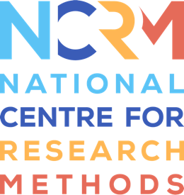
Focus Group - Introduction

Worksheet: Planning Your Focus Groups
Part of the resource: https://www.ncrm.ac.uk/resources/online/all/?id=20852

Run through the below considerations which are designed to help assist you in the planning of your focus groups:

Recruitment and focus group design:
- Consider how you will recruit participants for your focus group and the requirements of your participants in terms of accessibility and engagement in a focus group discussion.

- Consider the focus group format which will work best for your research question and/or objectives and your particular participant group (i.e. online or offline, workshop style, focus group guide with questions, or a combination of questions and workshop style activities):

- Consider how many focus groups will you facilitate.

- Consider the most appropriate and effective composition for your focus groups.

- Consider how many people do you want in each focus group and why.

- Consider how you will set up the space in which the focus group takes place whether this is in person (i.e. consider the room set up (tables and chairs), whether to include refreshments, lighting, sound, privacy, accessibility, etc.) or online (i.e. consider the platform you will use (such as Zoom or MS Teams), access requirements, its functionality, privacy and accessibility settings, etc).

Focus group agenda, questions and exercises:

- Plan your focus group agenda including: the questions you will ask, an appropriate order for these, and the inclusion of any focusing exercises or stimulus material which will engage your participants and focus their attention on the issue.

- Consider how you will build rapport at the beginning of the focus group, including the necessity of any ice-breaker activities or introductions.

- Consider possible group dynamics and conversational gambits – how might participants relate to the issue and engage with one another?

Focus group moderation

- Consider the role of the moderator and how the focus group will be moderated successfully. (I.e. What skills do they need to have? How will they ensure a successful discussion and interaction between participants?)

- Consider what other challenges or complications the moderator needs to be aware of?

- Consider how will you record and document the focus group discussion (i.e. note-taker, recording devices, transcription etc.)

Ethics and reflexivity

- Consider the ethics of planning and running your focus groups.

- Consider how you will reflect on each focus group session.

National Centre for Research Methods (NCRM)
Social Sciences
Murray Building (Bldg 58)
University of Southampton
Southampton SO17 1BJ
United Kingdom
Web www.ncrm.ac.uk
Email info@ncrm.ac.uk
Tel +44 23 8059 4539
Twitter @NCRMUK

